
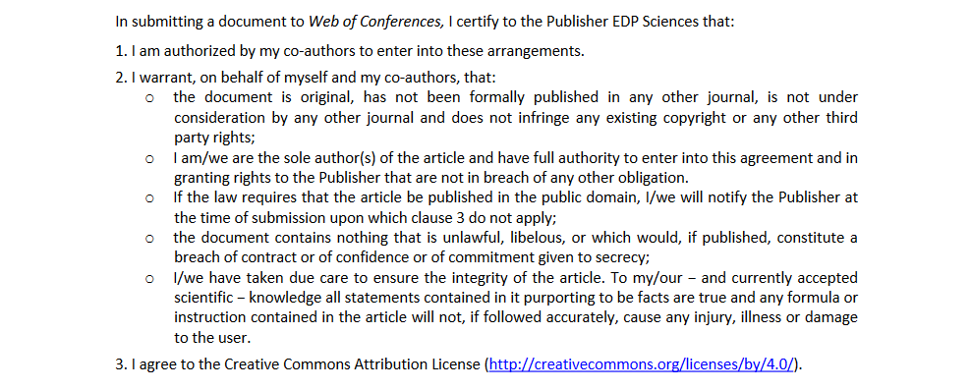

Title of the conference
International scientific online-conference “Bioengineering in the organization of processes concerning breeding and reproduction of perennial crops” (Krasnodar, Russian Federation, October 6 - 8, 2020)
Title of the document

Author(s)

Author’s signature

Date

17, avenue du Hoggar ‐ PA de Courtabœuf – BP 112 ‐ 91944 Les Ulis Cedex A (France)
Tél. : 33 (0)1 69 18 75 75 ‐ Fax : 33(0)1 69 07 45 17 – www.edpsciences. org

